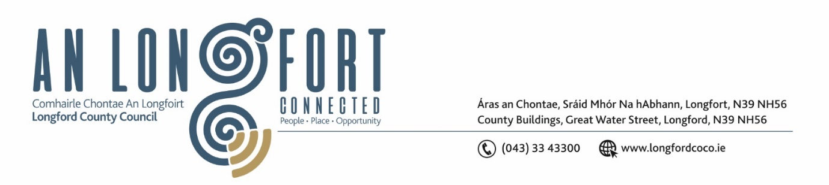
Minutes of Statutory Budget Meeting of Longford County Council
held in the Council Chamber and via Microsoft Teams on
Monday, 2 December 2024 at 4pm
__________________________________________________________________
PRESIDING: Councillor Mark Casey

MEMBERS PRESENT: Councillors Paul Ross, Paraic Brady, Peggy Nolan, Niall Gannon, Garry Murtagh, Gerry Hagan, Padraig McNamara, Martin Skelly, Seamus Butler, Uruemu Adejinmi, Mick Cahill, Pat O’Toole, Sean Mimnagh, David Cassidy, Kevin Hussey, Martin Monaghan, Turlough McGovern.

IN ATTENDANCE: Mr. Paddy Mahon, Chief Executive
Mr. John McKeon, Deputy Chief Executive
Ms. Barbara Heslin, Director of Services
Ms. Samantha Healy, Director of Services
Mr. Michael Nevin, A/Director of Services
Mr. John Brannigan, Director of Services

APOLOGIES: None

Mr. John McKeon, Head of Finance, thanked the Members for their attendance at the Budget meeting and stated that the presentation prepared will give an overview on how the Budget for 2025 was prepared. The Budget for 2025 for each Service Division will be presented in turn, allowing the Members to raise specific questions on each Division.

John thanked the Cathaoirleach and Members of the Council for their continued co-operation and support and for their participation in the workshops. John also thanked his team in the Finance Directorate, the Directors of Services, and their teams for the huge amount of work carried out in preparing the Draft Budget.

John McKeon, Head of Finance, stated that expenditure for 2025 is estimated at
€75.8m and income of €55.3m which in total will leave a shortfall of €20.46m to be funded through Local Property Tax and Rates.

John outlined the details of the Draft Budget for 2025 under the following headings –

- Budget Book Structure.
- Financial Position
- Challenges & Solutions for 2025
- Financial Position – start of 2024
- Acute Financial Challenges 2025
- Budget Assumptions for 2025
- Longford Strategic Business Plan 2025 -2029 The “Longford Strategy”
- 5 Pillar Proposals & 5 Key Decisions
- Current Regeneration Projects – 82 Projects Total Value €31.09m
- Known Critical Large Projects 2025 -2029
- Additional Income Raising Capacity from “Longford Strategy”
- Income and Expenditure 2025
- Sources of Income
- Income Configuration
- Expenditure by Service Division
- Expenditure Variance by Service Division
- Table D – Income from Goods and Services
- Table E – Income from Grants and Subsidies
- Table F – Analysis of Expenditure and Income by Service Division
- Commercial Rates
- Strategic Business Plan – Commercial Rates Proposal
- Return on Investment from Commercial Rates
- Commercial Rates increase of 5% to include the Small Ratepayer Support Scheme.
- Small Ratepayers Support Scheme that has been formulated to alleviate the effects on the smallest most vulnerable ratepayers in Co. Longford that will benefit 86% of Longford ratepayers.
The Members welcomed the Budget, they thanked John McKeon and the Finance Team for all the work involved.

The Executive replied to the issues raised by the Members, including the following –

- Maintenance of Local Authority housing
- Derelict Sites Levy
- Recreational & Amenities – Playgrounds, Walkways & Harbours
- Rates
- Service Support
- Income
- River Drainage
- Regeneration projects
- Civic Offices
- Rent Review
- The emerging shortfall from Housing Voids departmental funding.
- Public Conveniences
- Mini Street Sweeper (Multihog)
- Contactless Car Parking
- MD Allocation

On the proposal of Councillor Seamus Butler seconded by Councillor Paul Ross the members unanimously agreed to adopt for the financial year ending 31st December 2025, the Budget set out in Tables A – F, and by Resolution determined in accordance with the said Budget the Rate - €0.2647 - to be the annual rate on valuation to be levied for 2025 for the purposes set out in those Tables.

On the proposal of Councillor Seamus Butler seconded by Councillor Mick Cahill the members unanimously agreed under Section 9 of the Local Government Rates and Other Matters Act 2019, to the continuation of the existing vacant property abatement scheme, whereby Longford County Council will grant a write off equivalent to 100% of commercial rates invoiced during 2025.

Chief Executive Paddy Mahon thanked the Members for their attendance, he thanked them for their continued support, and thanked John McKeon and the Finance Team for all their work. This Budget is a Strategic Plan and is a framework for supporting our citizens for the term of this Council.

This concluded the business of the meeting.

Signed: _________________________
Lorraine McKee
Meetings Administrator

Confirmed and adopted at Meeting of Longford County Council held on the 15 January 2025

Signed: __________________________
Cathaoirleach

